Water cycle unit:

Kids interactive: scrabble, fun facts, guess gallons used…..*******
http://water.epa.gov/learn/kids/drinkingwater/gamesandactivies.cfm

water cycle song:

http://www.youtube.com/watch?v=okZBiy_IdBA

simple song:
http://www.youtube.com/watch?v=Yw275056JtA&feature=related

Magic school bus: water cycle
http://www.youtube.com/watch?v=AQKdkponoZM&feature=related

Experiment on youtube: “How to make it rain”
http://www.youtube.com/watch?v=QjSfIDARTik

Experiment on youtube: “How to make clouds in a bottle”
http://www.youtube.com/watch?v=E8AvfXar9zs&feature=related

Experiment on youtube: “How to make instant snow”
http://www.youtube.com/watch?v=PEDsRMKtDPY&feature=related

Exeperiment on youtube: “”How to make instant ice”
http://www.youtube.com/watch?v=WCFRFC_8rwk&feature=related

See experiment below:

Individuals, small groups, schools and families all around the world are helping fund new water wells and other water projects. You can too!
We've built the tools you need to make a real impact. Jump in today. We need your voice.

How to Get Involved

Every donation to The Water Project is linked to a specific project, no matter how much you give. But, if you'd like to sponsor an entire project on your own, or with your school or church, we want to help!

One of the best ways to help is to rally your friends and family. And we're making that easy. Setup your own page in minutes. Celebrate a birthday, run

  - Kenya »
  - Rwanda »
  - Sierra Leone »
  - Sudan »
  - Uganda »

Find Something
  - Your Project »
  - a Project your Group/School Funded »
  - a Fundraising Page »

Every Project, Every Donor, Every Time
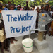
Our unique system let's you track your donation to specific project. Then, you can follow it, from construction to water flowing and into the future as we check up on it.
Maps, pictures, stories and details from the specific project you support connect you to the people you help.
http://thewaterproject.org/updates

See What's Happening Now »
- About
  - Who We Are »
  - Our Board & Staff »
  - Financials »
  - Corporate Campaigns »
  - FAQ »
  - Jobs »
- Contact

Contact Us
You can reach us via email at:
info (at) thewaterproject.org

Comments/Questions? Click Here »

Our Mailing Address:
The Water Project, Inc.
PO Box 3353
Concord, NH 03302
Our Offices:
4 Bicentennial Square
3rd Floor
Concord, NH 03301
+1 704-918-1804

Find us on social networks
- Donate
  - Donate Online »
  - The Sponsor's Team »
  - Donate by Check »
  - Shop Our Gift Store »
  - Monthly Giving »
  - Start a Fundraiser »

Make a mini water cycle!
We know that water can be a liquid, a gas, or a solid. Outside, water is always changing from liquid to gas and back again. This process is called the water cycle. You can see how the water cycle works.

The Water Cycle
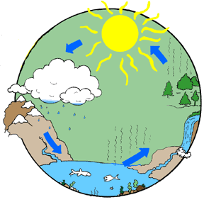
The sun's heat causes water to evaporate from streams, lakes, rivers, and oceans. The water vapor rises. When it reaches cooler air, it condenses to form clouds. When the clouds are full of water, or saturated, they release some of the water as rain.

Create Your Own
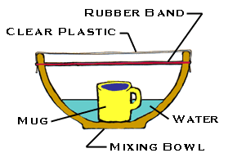
You will need:
- a large metal or plastic bowl
- a pitcher or bucket
- a sheet of clear plastic wrap
- a dry ceramic mug (like a coffee mug)
- a long piece of string or large rubber band
- water
- Put the bowl in a sunny place outside.
- Using the pitcher or bucket, pour water into the bowl until it is about ¼
full.
- Place the mug in the center of the bowl. Be careful not to splash any water into it.
- Cover the top of the bowl tightly with the plastic wrap.
- Tie the string around the bowl to hold the plastic wrap in place.
- Watch the bowl to see what happens.
The "mist" that forms on the plastic wrap will change into larger drops of water that will begin to drip. (You can speed up the dripping by carefully moving the bowl – don't splash! – into the shade.) When this happens, continue watching for a few minutes, then carefully peel back the plastic. Is the coffee mug still empty? Water from the "ocean" of water in the bowl evaporated. It condensed to form misty "clouds" on the plastic wrap. When the clouds became saturated it "rained" into the mug!
This experiment adapted from resources provided by the Monroe County Water Authority - http://www.mcwa.com/MyWater/KidsWaterFun.aspx#cycle

