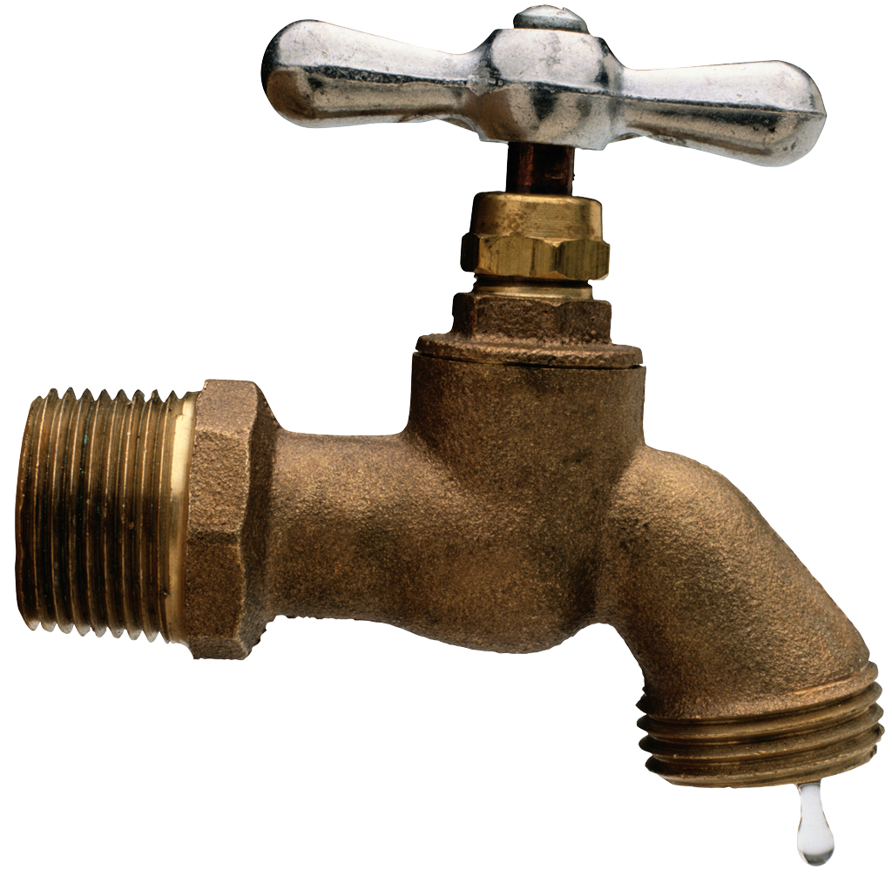The Water Cycle
Name _____________________________________

S4E3. Students will differentiate between the states of water and how they relate to the water cycle and weather.
a. Demonstrate how water changes states from solid (ice) to liquid (water) to gas (water vapor/steam) and changes from gas to liquid to solid.
b. Identify the temperatures at which water becomes a solid and at which water becomes a gas.
c. Investigate how clouds are formed.
d. Explain the water cycle (evaporation, condensation, and precipitation).
e. Investigate different forms of precipitation and sky conditions. (rain, snow, sleet, hail, clouds, and fog).

Students copy and use this website to answer questions:
http://water.epa.gov/learn/kids/drinkingwater/gamesandactivies.cfm

1. Explain evaporation:

2. Explain condensation

3. Explain precipitation:

4. Draw the four kinds of clouds: define them and tell how they are different:

